Acts of the Apostles
A Study of New Testament History
Lesson 9
Acts 9:1-43

Introduction:
The most fundamental foundation upon which the faith of every Christian rests is the indisputable fact that Jesus Christ was resurrected from the dead. The apostle Paul put it this way in the opening words of his letter to the church at Rome:

Paul, a bondservant of Jesus Christ, called to be an apostle, separated to the gospel of God which He promised before through His prophets in the Holy Scriptures, concerning His Son Jesus Christ our Lord, who was born of the seed of David according to the flesh, and declared to be the Son of God with power according to the Spirit of holiness, by the resurrection from the dead. (Romans 1:1-4)

It's often been said, if someone could be proven beyond any reasonable doubt that Jesus Christ was not resurrected from the dead, then our faith would be useless. Even the apostle Paul agreed with that assessment. In 1 Corinthians chapter 15 Paul wrote:

And if Christ is not risen, then our preaching is empty and your faith is also empty. Yes, and we are found false witnesses of God, because we have testified of God that He raised up Christ, whom He did not raise up — if in fact the dead do not rise. (1 Corinthians 15:14-15)

And if Christ is not risen, your faith is futile; you are still in your sins! Then also those who have fallen asleep in Christ have perished. If in this life only we have hope in Christ, we are of all men the most pitiable. (1 Corinthians 15:17-19)

There are numerous historical and Biblical proofs that provide ample evidence for believing that Jesus Christ was, in fact, resurrected from the dead. However, one of the most persuasive arguments for believing in the resurrection is found in the radical transformation that took place in the lives of those who knew Jesus.

One such example is that of the brothers of Jesus. We're told, "For even His brothers did not believe in Him" (John 7:5), and were probably among those of His own family who concluded, "He is out of His mind" (Mark 3:21). And yet, in the days following the crucifixion of Jesus a radical transformation took place. We find these same brothers of Jesus mentioned among the 120 disciples of the Lord (Acts 1:12-14). James, the Lord's brother wrote what is said to have been the first letter circulated among Christians (the book of James). Along with Peter and John, James is also referred to as one of the "pillars" among the disciples in Jerusalem (Galatians 1:19; 2:9 compared to Acts 15:13). Jude, the brother of James, wrote another epistle in which he boldly asserted that we must, "contend earnestly for the faith which was once for all delivered to the saints" (Jude 3). What could have made such a dramatic change in the lives of these men – transforming them from scoffers and unbelievers, into some of the most devoted disciples of the Lord? The answer? The indisputable evidence that Jesus Christ was resurrected from the dead and ascended into heaven to sit at the right hand of God.

But perhaps the most amazing transformation of all is that of the man known as Saul of Tarsus. Saul was a devout Pharisee, and a fierce persecutor of the Lord's disciples. We're told; "he made havoc of the church, entering every house, and dragging off men and women, committing them to prison" (Acts 8:3). As we learned from the previous lesson, the word "havoc" means to cause immense pain and suffering; to ravage or devastate. It is a word used to describe the merciless attack of a wild beast as it tears its prey to pieces. It seems strange that Saul, a student of Gamaliel, and a man educated to be a gentleman and a scholar, could be so vicious and merciless in persecuting others. And yet, he did more to completely eradicate the infant church than perhaps any other man of his time.

When we come to the ninth chapter of Acts we find Saul, "still breathing threats and murder against the disciples of the Lord" (Acts 9:1). He had set out for the city of Damascus, with letters from the high priest, to purge the synagogues there of every man or woman who was of "the Way." His purpose was to bring them bound back to Jerusalem where they would stand trial and face an almost certain death. However, Saul never completed his mission.

Jesus, whom Saul had believed was just another messianic imposter, spoke to him from a blinding light out of heaven, proclaiming "I am Jesus, whom you are persecuting" (Acts 9:5). We can only imagine the thoughts that must have raced through Saul's mind at that moment. He came face to face with the Savior whom he had denied, and whose disciples he had sought to annihilate. Despite the claims made by many in the denominational world, Saul was not saved on the road to Damascus. He was told to go into the city of Damascus and there he would be told what he must do. But there is no disputing the fact that in one brief moment of time, Saul went from unbeliever to believer.

Three days later Saul met Ananias, a disciple of the Lord, who told the former enemy of Christ what he must do to be saved. There was no need to tell Saul to believe nor repent. His encounter with Jesus on the road to Damascus was clearly enough to produce faith in Jesus was the Christ. And the fact that he had neither eaten nor drank for three days suggests the immense depth of Saul's sorrow – godly sorrow that would lead any man to repentance. All Ananias need to say to Saul was, "Arise and be baptized, and wash away your sins, calling on the name of the Lord" (Acts 22:16).

From an enemy of Christ to a man destined to become one of the Lord's most influential apostles, the story of that fateful trip to Damascus ends with these words:
Then Saul spent some days with the disciples at Damascus. Immediately he preached the Christ in the synagogues, that He is the Son of God. Then all who heard were amazed, and said, "Is this not he who destroyed those who called on this name in Jerusalem, and has come here for that purpose, so that he might bring them bound to the chief priests?" But Saul increased all the more in strength, and confounded the Jews who dwelt in Damascus, proving that this Jesus is the Christ. (Acts 9:19-22)

If Saul's encounter with Jesus Christ was not enough to convince a skeptic that Jesus had been resurrected from the dead, the events at the close of chapter nine would offer additional undeniable proof. Her name was Tabitha, which is also translated Dorcus. She was known for her good works of charity. When her friends heard that the apostle Peter was in the vicinity, they called for him.

Upon arriving and seeing how many were weeping over the passing of their friend, Peter sent them out of the room, knelt down to pray, and then said, "Tabitha, arise" (Acts 9:40). She did. The impact was immediate and widespread – "many believed on the Lord" (Acts 9:42). Tabitha was living, walking, talking proof of the power of the resurrection. And more than that, she was evidence that the power of the resurrected Christ had been bestowed on His apostles.

Memorization:
Then he fell to the ground, and heard a voice saying to him, "Saul, Saul, why are you persecuting Me?" And he said, "Who are You, Lord?" Then the Lord said, "I am Jesus, whom you are persecuting. It is hard for you to kick against the goads." (Acts 9:4-5)
Key Events of Acts 9:
- The Lord appears to Saul on the road to Damascus.
- Saul is baptized.
- Tabitha (Dorcus) raised from the dead.

Link to Online Bible Study Tools:
These websites contain numerous Bible Versions and Translations, Concordances, Dictionaries, Lexicons and many other useful tools: http://biblos.com/ and http://www.biblestudytools.com/ (Click on "Our Library" at the top of the home page)

The Exposition:
I. Saul's still actively persecuting the Lord's church (Acts 9:1-9)
A. Saul's journey to Damascus (Acts 9:1-2)
1. Describe Saul's attitude toward the disciples of the Lord. What does this tell you about Saul?

2. Using the map below, identify the approximate location of Jerusalem, Damascus, Caesarea, Lydda and Joppa.

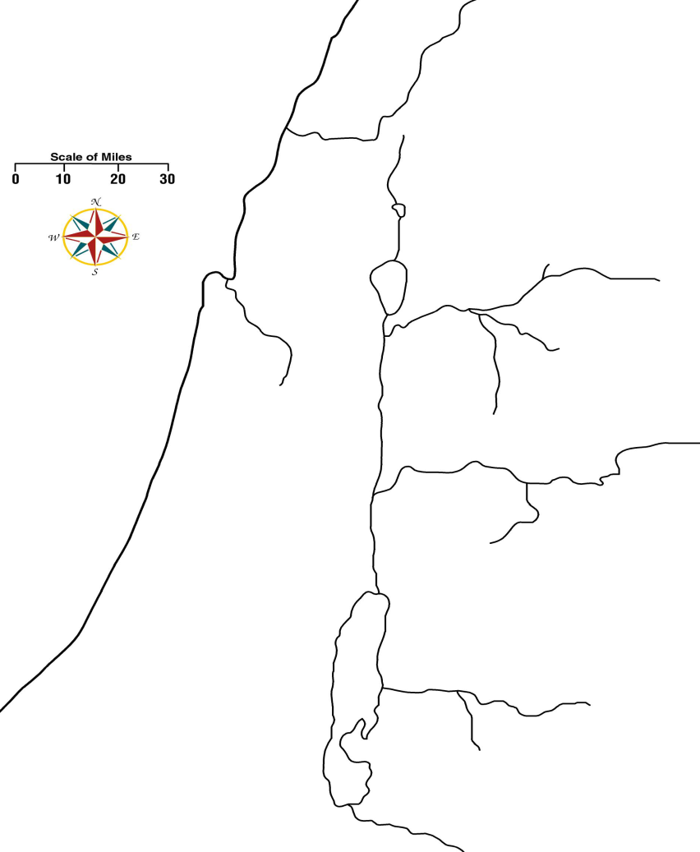
3. Use a Bible dictionary to give a brief history of Damascus up to the time of the apostles.

4. Why do you suppose Saul would look for disciples of the Lord in the synagogues of Damascus?

B. The Lord appears to Saul (Acts 9:3-9)
1. How was Saul persecuting Jesus? (v. 3) Explain your answer.

2. Explain the meaning of Jesus' statement in verse 5.

3. Explain Saul's state of mind at this moment. Do you think Saul had any doubts that Jesus was in heaven? Explain your answer.

4. What do you think might have been going through Saul's mind at the moment, and why would he ask this question, "Lord, what do You want me to do?"

5. What was the Lord's response?.

6. What was Saul's physical condition after the Lord appeared to him?

7. What in verses 3 through 9 indicate Saul was deeply troubled and remorseful from his encounter with Jesus?

8. Is there anything in verses 3 through 9 that would indicate Saul was actually saved on the road to Damascus?

9. What in these verses would indicate that Saul was not saved on the road to Damascus?

10. Skeptics claim there is a discrepancy in Luke's account between Acts 9:7 and Acts 22:9. How would you explain this alleged discrepancy?

II. Ananias and Saul (Acts 9:10-19)
A. Ananias (Acts 9:10-16)
1. What does the name Ananias mean?

2. How is Ananias described by Luke?

3. What did the Lord ask Ananias to do?

4. What was Ananias' reaction?

5. Read the Lord's reply in Acts 9:15-16 and answer the following questions.
a. Compare these verses with Galatians 1:1; Ephesians 1:1; 1 Timothy 1:1; 2:5-7. What is implied by Saul being a "chosen vessel"?

b. How did the Lord describe Saul's mission?

c. What would be the consequences of Saul's mission?

B. Ananias and Saul (Acts 9:17-19)
1. How did Ananias explain his visit to Saul?

2. From what we learned in Acts 8:14-19, how do you think Ananias received the power to lay hands on Saul and restore his sight?

3. Since Ananias was not an apostle and could not impart the power of the Holy Spirit to Saul, how do you think Saul became "filled with the Holy Spirit?

4. Compare Acts 9:18 with Acts 22:16. Why was Saul baptized?

5. What did Saul do immediately after he was baptized?

III. Saul preaches Christ (Acts 9:20-31; Galatians 1:13-24)
A. Saul in Damascus (Acts 9:20-22)
1. What did Saul do immediately after he was baptized?

2. What was the reaction of those hearing Saul's preaching?

B. A three year interlude (Galatians 1:13-17)
1. Although Luke does not mention this three year interlude, the apostle Paul does. Where did Paul go during this time?

C. Saul Returns to Damascus (Acts 9:23-25)
1. Why would the Jews have sought to kill Saul?

2. How did he escape?

D. Saul in Jerusalem (Acts 9:26-31; Galatians 1:18-24)
1. What was the reaction among disciples of the Lord in Jerusalem over Saul's conversion?

2. Who vouched for Saul, and what did he say about Saul? Where do we first read about this man?

3. According to Galatians 1:18-20, who did Saul see while in Jerusalem and with whom did he stay?

4. According to Acts 9:29, what was the reaction in Jerusalem to Saul's preaching?

5. What did the brethren do?

6. According to Galatians 1:21, where did Saul go after leaving?

7. What is one of the principle cities of Cilicia, and why would Saul go there? (See the map on page 13)

8. According to Acts 9:31 and Galatians 1:22-24, what was the impact of Saul's conversion on the church in Judea, Galilee and Samaria?

IV. Peter performs miracles (Acts 9:32-43)
A. Aeneas (Acts 9:32-35)
1. Where was Peter at this time?

2. What did he do there?

3. What was the impact of what Peter did?

B. Tabitha (Acts 9:36-43)
1. Who is Tabitha and what was she known for doing?

2. What could have been the reasons for the disciples asking Peter to come immediately?

3. What did the widows show Peter? What does this suggest about the kind of "good works and charitable deeds" Tabitha did?

4. What did Peter ask the people in the room to do? Why do you think he might have done this? Can you think of another example where someone did something similar?

5. What did Peter do?

6. What was the impact of what Peter did?

7. Where did Peter stay?

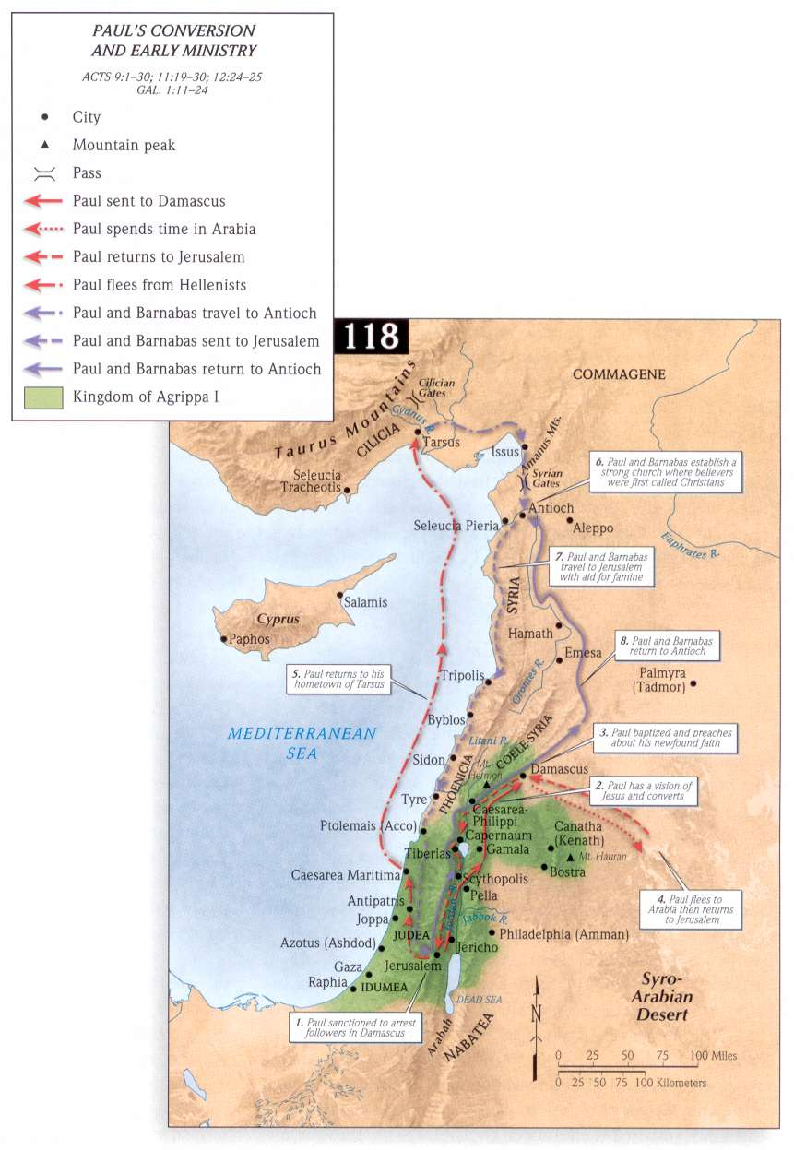Application:
Be prepared to discuss what lessons can learn from these events, and how those lessons can be applied to present-day situations.

