Acts of the Apostles
A Study of New Testament History
Lesson 22
Acts 27:1-44
Paul's Journey to Rome – Part One

Introduction:
The story of Paul's voyage is unlike any other story in the Bible. This section of Luke's treatise does not deal with deep spiritual teachings or acts of devotion, but rather the everyday life one normally experienced at sea during that period of history. Luke gave us a detailed account of all the islands, towns and harbors along the journey. However, what makes this account of the journey of Paul so unique is that Luke gave us a description of first century ships and seamanship that surpasses any other voyage recorded in ancient Greek or Roman literature. In many ways it stands as a descriptive masterpiece of what it was like to navigate the treacherous Mediterranean Sea in wooden sailing ships. It reads more like a fascinating adventure than Scripture.

Throughout the book of Acts Luke has presented the apostles as mere men. He seemed to intentionally avoid describing these men as superheroes of the faith. Instead he describes them as men devoted to the single, holy purpose of preaching and teaching the gospel of Jesus Christ. However, that does not lessen the fact that these were also men of great courage and unwavering faith – men who bravely faced hardships, the constant threat of persecution, and even death.

When reading the account of Paul's voyage to Rome, one thing becomes clear. Paul is a man among men. He began the voyage as a prisoner among other prisoners, but gradually assumed a position of respect and even command. His cool courage, common sense, and resourcefulness set him apart again and again under increasingly dangerous circumstances. Even though he acknowledged God as the source of every blessing, and despite completing the journey still a prisoner that does not diminish the fact that Paul was still a hero of the faith. He proved himself to be the best kind of man to have in an emergency.

The journey of Paul to Rome covered approximately 2,250 miles – all but the last 150 miles were spent at sea. The journey occurred around AD 60-61 and took the better part of 18 months to complete. Fortunately for Paul, he was not alone during this journey. Some commentators note that this section of Acts is the longest "we" section in the book, meaning Luke was Paul's companion throughout the entire journey. Although Luke and Paul were separated for a time following the apostle's arrest in Jerusalem at the conclusion of his third missionary journey, they were together again during the journey to Rome. Whether Luke made this journey at his own expense or, as some have suggested, at the expense of the Roman government, is not stated. Some suggest Luke was allowed to accompany Paul as an attendant or servant of the apostle, which was apparently a common practice in that day. One commentator even suggests that Luke, as a physician, would have been a welcomed passenger on the voyage and may have even served as the ship's physician. However, all this is merely conjecture, albeit quite feasible.

Aristarchus, a Macedonian of Thessalonica, also journeyed with Paul to Rome. While imprisoned in Rome, the apostle Paul referred to Aristarchus as a "fellow prisoner" Col 4:10). If the term "fellow prisoner" is taken literally, as many commentators seem to think, then Aristarchus had also arrested at some point and had also been sent to Rome (perhaps having also appealed to Caesar). If, however, the term "fellow prisoner" is taken figuratively, then perhaps Aristarchus left Paul at some point during the journey only to rejoin Paul later in Rome. The reasoning behind this latter theory is that Aristarchus is only mentioned at the beginning of the voyage. However, the "we" Luke uses throughout this portion of Acts could have easily included Aristarchus as well.

Memorization:
Acts 27:22 – "And now I urge you to take heart, for there will be no loss of life among you, but only of the ship."

Key Events of Acts 27:1-44
- Paul sets sail accompanied by Luke and Aristarchus
- Paul's warnings ignored
- The storm at sea
- The shipwreck

Link to Online Bible Study Tools:
These websites contain numerous Bible Versions and Translations, Concordances, Dictionaries, Lexicons and many other useful tools: http://biblos.com/ and http://www.biblestudytools.com/ (Click on "Our Library" at the top of the home page)

The Exposition:
I. Paul begins his journey to Rome (Acts 27:1-12)
A. Paul sets sail with Luke and Aristarchus (Acts 27:1-7)
1. Who is the Roman centurion in charge of Paul and the other prisoners?

2. Where did Paul and the others board the first ship?

3. Using a Bible dictionary or other reference, give a brief biography of Aristarchus and list the passages where he is mentioned.

4. How did the Roman centurion treat Paul when they arrived the next day at Sidon.

5. What happened at their next port-of-call in Myra, a city of Lycia?

6. What slowed the journey during this part of the voyage?

B. Paul's warnings ignored (Acts 27:9-12)
1. Consulting a commentary, what "Fast" would Luke be referring to in verse 9, and why did that indicate the sailing season was now dangerous?

2. What prediction did Paul give concerning the voyage if they sailed at this time?

3. Why was his warning ignored?

II. The Storm at Sea (Acts 27:13-38)
A. Smooth sailing at first (Acts 27:13-14)
1. How did this part of the voyage begin?

2. What happened after sailing past Crete? Use a Bible dictionary or some other source to define "Euroclydon."

B. Sailing into the storm (Acts 27:15-38)
1. What did they do during the first day of the storm?

2. What did they do on the second day?

3. What did they do on the third day?

4. What did Paul say to encourage the crew and passengers?

5. How did Paul say the voyage would end?

6. What happened on the "fourteenth night" of the storm?

7. What were the sailors trying to do?

8. What did Paul say to the centurion and the soldiers, and what did they do?

9. What did Paul do as the "day was about to dawn"?

10. What assurance did Paul give the crew and passengers, and what did he do to encourage them to eat?

11. How many were aboard the ship?

12. What did the crew do next?

III. The shipwreck (Acts 27:39-44)
A. Heading for shore (Acts 27:39-41)
1. When they saw a bay with a beach what did the crew purpose to do?

2. What steps did they take to run the ship aground?

3. What happened to the ship after it ran aground some distance from shore?

B. The centurion intervened to save the lives of Paul and the other prisoners (Acts 27:42-44)
1. What did the soldiers plan to do with the prisoners, and why?

2. What did the centurion do?

3. How did everyone reach shore?

4. Use the map below to trace the journey to this point.
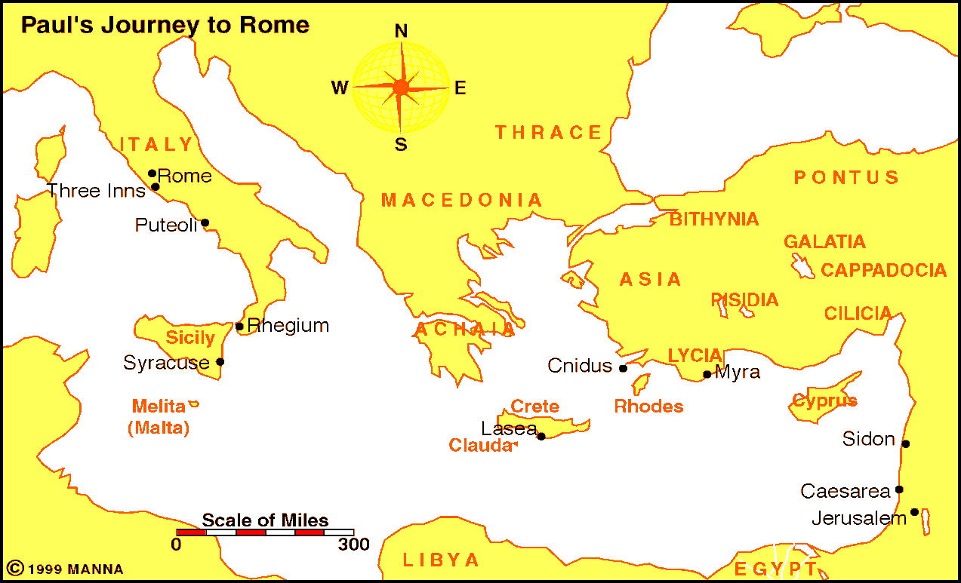

Application:
Be prepared to discuss what lessons can learn from these events, and how these lessons can be applied to present-day situations.

