Acts of the Apostles
A Study of New Testament History
Lesson 17
Acts 18:23 – 19:41
Paul's Third Missionary Journey – Part 1

Introduction:
Upon his return from his second missionary journey, the apostle Paul wasted no time in launching into his third trip. We are told:

And when he had landed at Caesarea, and gone up and greeted the church, he went down to Antioch. After he had spent some time there, he departed and went over the region of Galatia and Phrygia in order, strengthening all the disciples. (Acts 18:22-23)

Several commentators have suggested that Paul's brief stay in Antioch of Syria was due to the fact that Paul had learned that false teachers had been sent to Corinth and to the churches in Galatia with letters of commendation (2 Cor 3:1), and preaching another gospel (Gal 1:6; 2 Cor 1:4). They were Judiazing teachers who were preaching the necessity of holding to certain aspects of the Law of Moses (such as circumcision and the keeping of certain holy days) to be acceptable to God. Despite the fact that this issue had been settled during the meeting of the apostles and elders in Jerusalem (Acts 15), and that Paul and Silas had personally delivered letters confirming this decision to the churches in Derbe, Listra and Iconium, it is only reasonable to assume some of these Judiazing teachers were not ready to surrender to the apostles' decision.

Therefore, Paul's primary purpose during this third journey will be to strengthen the brethren in the churches he has already helped to establish. During this time Paul will also write letters to the church in Corinth (1 and 2 Corinthians), the churches in Galatia (Galatians), and the church in Rome (Romans). These three letters will carry a common theme of stressing faithful obedience to the gospel of Christ, and the need to recognize that Christians are no longer subject to the Law of Moses.

It seems that Paul sets out on this third journey alone, with the possibility that he was also accompanied by Timothy. The only evidence suggesting Timothy was with Paul is that the two are together again in Ephesus (Acts 19:22). What became of Silas? The truth is that we are uncertain where Silas may have been during the latter part of Paul's second missionary journey as well as during his third journey. The narrative in Acts implies that Paul may have left Athens and reached Corinth before Timothy and Silas were able to join him there. Their arrival in Corinth is implied by Paul statement concerning "the brethren who came from Macedonia" (2 Cor 11:9). It is also implied by Acts 18:18 that Silas did not leave Corinth at the same time as Paul, but what became of Silas after that point is unclear. If Silas is Silvanus, which virtually every commentator agrees, then he is mentioned along with Paul and Timothy as having preached Christ among the Corinthians (compare 2 Cor 1:19 with Acts 18:5). In 1st and 2nd Thessalonians Silvanus was apparently known by the brethren in Thessalonica because all three send greetings to the church there (1 Thess 1:1, and 2 Thess 1:1; compare to Acts 17:1-9). In 1st Peter Silvanus is mentioned as a "faithful brother" who took Peter's letter to the churches of the Dispersion (1 Pet 1:1; 5:12). Other than those references we have no further indication of what became of Silas (Silvanus).

During Paul's third journey we read "he departed and went over the region of Galatia and Phrygia in order, strengthening all the disciples" (Acts 18:23). Luke also adds "Paul, having passed through the upper regions, came to Ephesus" ( Acts 19:1). The ministry of Apollos in Ephesus (Acts 18:24-28) had taken place before Paul arrived, and while Aquila and Priscilla were still there. From there Apollos went Corinth to work with the church there (perhaps with the recommendation of Aquila and Priscilla). But after becoming innocently embroiled in the strife there (1 Cor 1-4), Apollos left Corinth and refused to return even after Paul's request (1 Cor 16:12).

There are several key events that take place in Ephesus during the first part of Paul's four year-long third missionary journey (AD 54-58):
- Paul finds disciples of John the Baptist who were ignorant of John's teaching about repentance, Jesus, the Holy Spirit and baptism (Acts 19:2-7).
- Paul's preaching Christ in the synagogue for three months resulted in having to move to the school of Tyrannus where he preached for 2 years (Acts 19:8-10)
- The impact of Paul's work in Ephesus was that "all who dwelt in Asia heard the word of the Lord Jesus, both Jews and Greeks" (Acts 19:10). This would result in the founding of the church at Colossae and the other churches of Asia mentioned in Revelation 1:11.
- Paul's miracles and preaching also led to the wholesale rejection of magical arts and burning of magic books (Acts 19:11-20)
- Paul's preaching of Jesus Christ led to a riot in Ephesus (the center of the worship of Diana) prompted by Demetrius and other craftsmen of the city who were losing money from their trade of manufacturing shrines and statues of the goddess (Acts 19:23-41).

Memorization:
Acts 19:4-5 – Then Paul said, "John indeed baptized with a baptism of repentance, saying to the people that they should believe on Him who would come after him, that is, on Christ Jesus." When they heard this, they were baptized in the name of the Lord Jesus.

Key Events of Acts 18-19:
- Paul returns to strengthen churches previously established
- Apollos and his meeting with Aquila and Priscilla
- Paul finding those who knew only the baptism of John
- The effect of Paul's preaching spreads throughout all Asia
- The riot in Ephesus over Paul's preaching against idolatry

Link to Online Bible Study Tools:
These websites contain numerous Bible Versions and Translations, Concordances, Dictionaries, Lexicons and many other useful tools: http://biblos.com/ and http://www.biblestudytools.com/ (Click on "Our Library" at the top of the home page)

The Exposition:
I. During Paul's journey to Ephesus (Acts 18:23-28)
A. Paul strengthens the brethren (Acts 18:23)
1. What were the regions through which Paul traveled to strengthen the brethren?

2. What would most likely be the principle cities of these regions?

B. Apollos (Acts 18:23-28)
1. Who was Apollos and how does Luke describe him?

2. What was his understanding about baptism and what would that imply?

3. What did Aquila and Priscilla do?

4. Where did Apollos want to go to preach? What specific city would be implied?

5. Who wrote exhorting the disciples to receive Apollos? Why do you thing this was necessary? Explain your answer.

6. What did Apollos do when he arrived, and how did he refute the Jews?

II. Paul's time in Ephesus (Acts 19:1-41)
A. Disciples who knew only the baptism of John (Acts 19:1-7)
1. What was the question Paul posed to some of the disciples he found in Ephesus? What is implied by this question?

2. What did they know about the Holy Spirit?

3. How did Paul explain the purpose of John's baptism?

4. When these disciples understood they needed to accept Jesus Christ what did they do? What does this suggest one should do when they realized they were baptized for the wrong reasons?

5. What did Paul do after he baptized them and what were they able to do as a result?

B. Paul begins preaching (Acts 19:8-10)
1. Where was the first place Paul went to preach and how long did he preach there?

2. We're told Paul was "reasoning and persuading concerning the things of the kingdom of God." What is implied by the phrase "the kingdom of God"? (Compare Acts 19:8 with Acts 8:12) Explain your answer.

3. What was the reaction of some to Paul's preaching?

4. What words does Luke use to describe those who are believers in Jesus Christ?

5. Where did Paul go to preach after leaving the synagogue and how long was he there?

6. What was the impact of Paul's preaching in Asia?

7. From what you read in the introduction, what churches would have been established in Asia as a result of Paul's preaching in Ephesus?

C. Paul performs many miracles (Acts 19:11-20)
1. What were some of the "unusual" miracles that were done by the hands of Paul?

2. Who are "itinerant Jewish exorcists" and what did they do, including the seven sons of Sceva, a Jewish chief priest?

3. What did the evil spirit say in response, and what happened then?

4. What was the impact of this incident on the Jews and Greeks dwelling in Ephesus?

5. What did those who practiced magical arts do?

6. What impact did all this have on the spread of the gospel?

C. The riot in Ephesus (Acts 19:21-41)
1. Where was Paul planning to go before returning to Jerusalem, and where did he eventually want to go?

2. What was the "great commotion about the Way" that rose up at that time?

3. What was the reaction of the residents of Ephesus?

4. What did Paul want to do and why was he restrained?

5. Who did the Jews want to address the confused crowd and what was their reaction?

6. What did the city clerk say to the crowd about their belief concerning Diana?

7. What did he propose the craftsmen of the city do to resolve this situation and why did he offer this proposal?

III. Paul's Third Missionary Journey – Part 1
1. Identify the cities during the first part of Paul's journey (Antioch to Ephesus).
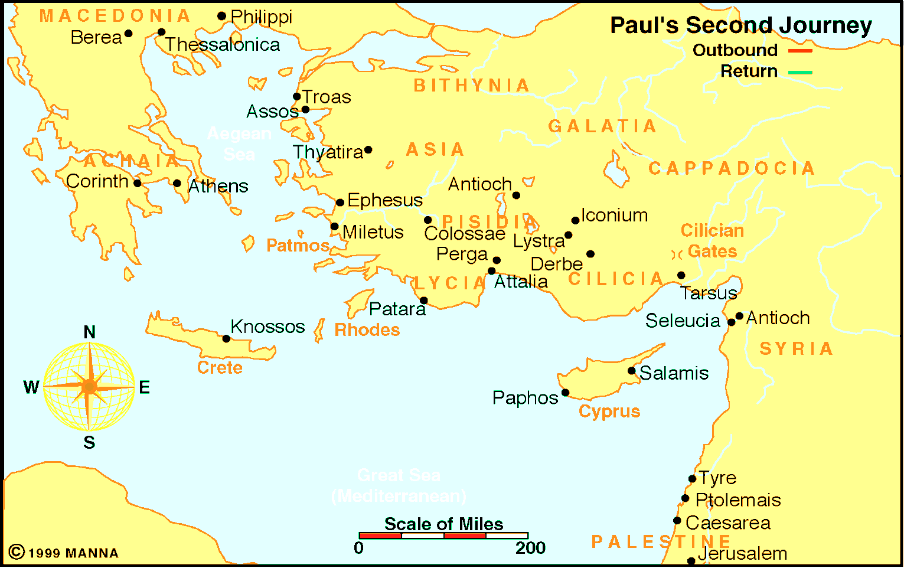

From Athens to Antioch

Application:
Be prepared to discuss what lessons can learn from these events, and how those lessons can be applied to present-day situations.

