Acts of the Apostles
A Study of New Testament History
Lesson 16
Acts 17:15 – 18:22
Paul's Second Missionary Journey – Part 1

Introduction:
The second half of Paul's second missionary journey begins with the apostle traveling to Athens, Corinth and Ephesus, and ends with his return to Antioch in Syria where he remains briefly before leaving for Galatia and Phrygia to strengthen the disciples. During this part of his second missionary journey Paul will meet Aquila and Priscilla who will play a major role in helping to ground the church in Corinth, and whom Paul will take with him to Ephesus and leave there to help that newly established church.

Paul's Second Missionary Journey – Part 2 includes the following significant events:
- Athens
  - Paul taught to all who would listen in synagogues, in market places, and Mars Hill
- Corinth
  - Stayed with Aquila and Priscilla (worked as a tentmaker)
  - Paul preached in the synagogue every Sabbath
  - Timothy and Silas join Paul bringing good news from Macedonia
  - Justus converted
  - Crispus and his household converted
  - 1 & 2 Thessalonians written to church in Thessalonica
  - Paul remained in Corinth 1 ½ years
  - Jews accuse Paul of persuading men "to worship God contrary to the law"
- Ephesus
  - Paul preached briefly in the synagogue
  - Left Priscilla and Aquila at Ephesus
- Sailed to Caesarea (possibly went to Jerusalem to celebrate "feast"
- Antioch in Syria
  - Remained in Antioch for a time before leaving for Galatia and Phrygia to strengthen the disciples

Memorization:
Acts 18:9-10 – Now the Lord spoke to Paul in the night by a vision, "Do not be afraid, but speak, and do not keep silent; for I am with you, and no one will attack you to hurt you; for I have many people in this city."
Key Events of Acts 17-18:
- Paul's sermon on Mars Hill
- The establishment of the church at Corinth and Ephesus

Link to Online Bible Study Tools:
These websites contain numerous Bible Versions and Translations, Concordances, Dictionaries, Lexicons and many other useful tools: http://biblos.com/ and http://www.biblestudytools.com/ (Click on "Our Library" at the top of the home page)

The Exposition:
I. Athens (Acts 17:16-32)
A. A city given to idolatry (Acts 17:16-21)
1. Who was Paul expecting to join him in Athens?

2. What was Paul's reaction to the idolatry of the Athenians?

3. What was the first thing Paul did upon his arrival in Athens?

4. Where else did Paul reason with people?

5. From a Bible dictionary or other source briefly explain the philosophies of the Epicureans and the Stoics.

6. Why did the Epicurean and Stoic philosophers consider Paul a "babbler" while others considered him to be "a proclaimer of foreign gods"?

7. From a Bible dictionary or other source where is the Areopagus, what is the meaning of the name, and what generally happened there? (The Romans called this place Mars Hill)

8. What was Paul asked to do there, and why?

B. Paul's sermon on Mars Hill (Acts 17:22-31)
1. Why do you think Paul began his sermon with a compliment?

2. Rather than begin by condemning their idolatry, what did Paul say to pique their interest?

3. How does Paul establish the supremacy of the one true God over the false gods of the Greeks?

4. Where does the God of heaven not dwell?

5. Why is the one true God not worshipped with things created by the hands of men?

6. What subtle message to these Greeks was Paul trying to get across in verse 26?

7. The gods of the Greeks were considered to be detached from the concerns of humankind and unapproachable. What does Paul say in verses 27-28 about the nature of the one true God?

8. Why would "something shaped by art and man's devising" not be able to capture the true "Divine Nature" of God – even though it was formed by gold, silver or stone?

9. What is the meaning of the phrase "these times of ignorance God overlooked"? What did God overlook and why?

10. What does God now require of all men, and why?

11. What assurance did Paul give of a time when the world will be judged?

12. Who was Paul speaking about?

C. The reaction to Paul's preaching (Acts 17:32-34)
1. Why would some mock Paul upon hearing about the resurrection of the dead?

2. What was the reaction of others to Paul's preaching?

3. From a Bible dictionary or other source explain the meaning of the word Areopagite.

II. Corinth (Acts 18:1-17)
A. Preaching in Corinth (Acts 18:1-11)
1. Who were the first people Paul met in Corinth and what did they share in common?

2. To whom did Paul do most of his preaching during the early days in Corinth?

3. Who joined Paul in the work at Corinth?

4. When the Jews opposed Paul for preaching that "Jesus is the Christ" what did he do, and how did this change his mission as an apostle?

5. What was the effect of the conversion of Crispus, the rule of the synagogue, and his household?

6. What did the Lord mean by the phrase "I have many people in this city", and what should this tell us about our own city?

7. How long did Paul work with the church in Corinth, and what did he do there?

8. Read the following passages and answer the questions below: 1 Corinthians 9:1-18; 2 Corinthians 11:5-10; Philippians 4:10-20.
a. What arguments does Paul make to justify being financially supported to preach the gospel? (1 Corinthians 9:7-13)

b. What did Paul mean by the statement, "If we have sown spiritual things for you, is it a great thing if we reap your material things." (1 Corinthians 9:11)

c. Why did Paul and those with him refuse financial support from the church at Corinth while working with the church there? (1 Corinthians 9:12, 15, 18; 2 Corinthians 11:7-9)

d. Explain the statement, "the Lord has commanded that those who preach the gospel should live from the gospel." (1 Corinthians 9:14)

e. What was Paul's attitude toward preaching the gospel – whether or not he received financial support for doing so? (1 Corinthians 9:16-17)

f. How does Paul describe the financial support he received from the church at Philippi? (Philippians 4:15-18)

g. What was Paul's prayer concerning the gift he received from the Philippians? (Philippians 4:19)

B. Opposition in Corinth (Acts 18:12-17)
1. What were the charges against Paul that the Jews brought before Gallio, proconsul of Achaia? Were these charges true? Explain.

2. What was Gallio's response?

3. Who was Sosthenes and what happened to him? Where else do we read about this man?

III. Paul's return trip (Acts 18:18-23)
A. Ephesus (Acts 18:18-21)
1. Who did Paul take with him when he left Corinth?

2. Why did Paul cut off his hair while in Cenchrea?

3. It is believed that Paul was keeping a Nazarite vow. What was the Nazarite vow and what was the purpose for making this vow? (Consult a commentary, Bible dictionary or some other source)

4. Who did Paul leave in Ephesus?

5. Where did Paul go to reason with the Jews?

6. Paul did not stay long in Ephesus because he wanted to return to Jerusalem for a "feast" (probably Passover). If Paul was not keeping the Law of Moses why do you think he was eager to keep the Passover?

7. What promise did Paul make to the Ephesians?

B. Caesarea, Antioch of Syria and the regions of Galatia and Phrygia (Acts 18:22-23)
1. What did Paul do in Caesarea before returning to Antioch?

2. Why did Paul return to the regions of Galatia and Phrygia?

VI. Paul's Second Missionary Journey – Part 2
- Identify the cities during the second part of Paul's journey (Athens to Antioch).
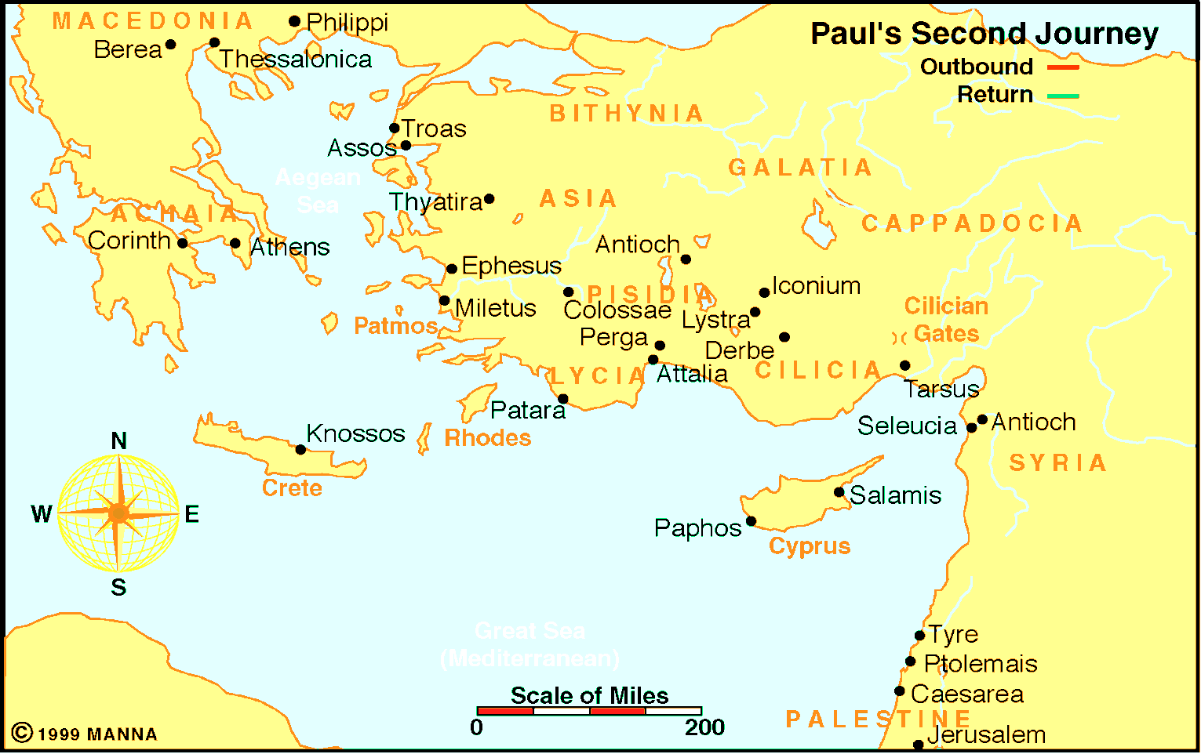

From Athens to Antioch

Application:
Be prepared to discuss what lessons can learn from these events, and how those lessons can be applied to present-day situations.

