Acts of the Apostles
A Study of New Testament History
Lesson 15
Acts 15:30 – 17:14
Paul's Second Missionary Journey – Part 1

Introduction:
The second missionary journey of the apostle Paul begins with the events following the meeting in Jerusalem (Acts 15:1-29), and ends with his return to Antioch in Syria (Acts 18:22). In the next two lessons (Paul's Second Missionary Journey Part 1 and Part 2) we will be taking a close look at Paul's work as an apostle of Jesus Christ as he takes the gospel throughout Asia Minor and finally into Europe (beginning with Thessalonica and ending with Corinth). This journey will take approximately three years (ca. AD 50-53) and cover a distance of about 2,700 miles (1,290 by sea, 1,410 by land). During this time Paul, working with Silas, established a number of congregations of the Lord's church throughout Asia and Europe, and wrote two letters to the church at Thessalonica while in Corinth (AD 52-53).

Paul's Second Missionary Journey – Part 1 includes the following significant events:
- Antioch
  - Paul and Barnabas separate over the issue of John Mark
  - Paul and Silas leave for Tarsus
  - Barnabas and Mark go to Cyprus
- Derbe and Lystra
  - Timothy joins Paul and Silas
- Phrygia and Galatia
  - Decree from Jerusalem delivered
  - Paul stricken with sickness
  - Forbidden by the Holy Spirit to go into the Roman Province of Asia
- Troas
  - Paul received the "Macedonian call"
  - Luke joins Paul and Silas
- Philippi
  - Conversion of Lydia
  - Paul and Silas imprisoned
  - Conversion of the Philippian jailer and his household
- Thessalonica
  - Reasoned in the Jewish synagogue
  - Paul accused of treason (his life is in danger)
  - Brethren send Paul and Silas away
- Berea
  - Jews from Thessalonica come to Berea and stir up trouble
  - Brethren send Paul away by sea

Memorization:
These were more fair-minded than those in Thessalonica, in that they received the word with all readiness, and searched the Scriptures daily to find out whether these things were so. (Acts 17:11)
Key Events of Acts 15-17:
- Paul and Barnabas separate over John Mark (Paul takes Silas, Barnabas takes Mark)
- Paul receives the "Macedonian call"
- Churches established in Philippi, Thessalonica, Berea, and Corinth

Link to Online Bible Study Tools:
These websites contain numerous Bible Versions and Translations, Concordances, Dictionaries, Lexicons and many other useful tools: http://biblos.com/ and http://www.biblestudytools.com/ (Click on "Our Library" at the top of the home page)

The Exposition:
I. Syria and Cilicia (Acts 15:30 – 41)
A. Antioch (Acts 15:30-35)
1. What was the reaction of the Antioch church over the letter from the apostles in Jerusalem?

2. How are Judas and Silas described, and what did they do?

3. What are some of the things prophets did in the early days of the Lord's church? (See: Acts 11:27-29; 13:1-3; 15:32; 1 Cor 12:28-29; 14:1-5, 22, 24-25, 29-33; Eph 4:11-16)

4. What did Paul and Barnabas and others do while they remained in Antioch?

B. Division over John Mark (Acts 15:35-41)
1. What did Paul propose to Barnabas?

2. Whom did Barnabas want to take with them?

3. What was Paul's reaction, and why did he react this way?

4. Do you think Paul's objections were justified? Explain why or why not.

5. What was the outcome of the disagreement between Paul and Barnabas?

II. Galatia and Phrygia (Acts 16:1-10)
A. Timothy joins Paul and Silas (Acts 16:1-3)
1. How does Luke describe Timothy?

2. Why did Paul have Timothy circumcised?

3. In light of the letter from the apostles and elders at Jerusalem, how do you think Paul justified requiring Timothy to be circumcised?

B. Derbe, Lystra and Iconium (Acts 16:4-5)
1. What did Paul, Silas and Timothy do through the cities in that region?

2. What was the effect of that they did?

III. Asia (Acts 16:6-10)
A. Forbidden to preach (Acts 16:6-8)
1. When Paul and those with him arrived in the province of Asia what did the Holy Spirit do?

B. Macedonian call (Acts 16:9-10)
1. Where was Paul when he had a vision?

2. What was the vision Paul had?

3. What did Paul do?

IV. Philippi (Acts 16:11-40
A. Conversion of Lydia and her household (Acts 16:11-15)
1. What cities did Paul pass through on his way to Philippi?

2. What did Paul and those with him do on the Sabbath? Why do you think they would they chose to do this on the Sabbath?

3. Who did they meet at the riverside, what was her occupation, and where was she from?

4. What was her reaction, and the reaction of her household, to Paul's preaching?

B. Paul and Silas arrested and imprisoned (Acts 16:16-24)
1. What happened when Paul and the others went to prayer?

2. What is the "spirit of divination"? (Consult a Bible commentary or dictionary)

3. What was this slave girl saying about Paul and the others, and why would this disturb Paul?

4. What did Paul do, and what was the reaction of the slave girl's masters?

5. What were the charges brought against Paul and Silas, and what was the reaction of the magistrates?

6. How were Paul and Silas punished?

C. Conversion of the Philippian jailer and his household (Acts 16:25-34)
1. What were Paul and Silas doing at midnight? What does this say about their conviction?

2. What happened when the earthquake struck?

3. What was the keeper of the prison about to do when he thought the prisoners had escaped?

4. What was the question the jailer asked Paul and Silas, and why do you think he would ask this?

5. What answer did Paul and Silas give the jailer?

6. Does the reply to the jailer teach salvation by faith alone – meaning baptism is not essential to salvation? Explain your answer.

7. What did Paul and Silas do to "him and to all who were in his house"?

8. What did the jailer and his family immediately do upon hearing the word of the Lord? What time of day would this have been?

9. Some who believe in sprinkling and pouring as acceptable forms of baptism argue that the jailer was baptized in this manner. Where do you think the jailer and his family were baptized, and why? Explain your answer.

10. What was the reaction of the jailer and his family after "having believed in God"?

D. Paul and Silas refuse to depart secretly (Acts 16:35-40)
1. What did the magistrates want to do the following morning, and what was Paul and Silas' reaction?

2. What was the reaction of the magistrates, and why did they reaction this way?

3. Where did Paul and Silas go after being released and what did they do?

V. Thessalonica (Acts 17:1-9)
A. Paul reasons from the scriptures in the synagogue (Acts 17:1-4)
1. What cities did Paul and those with him go through on their way to Thessalonica?

2. What did Paul do for the next three Sabbaths and why was it "his custom"? Does this mean Paul kept the Sabbath?

3. What was the initial reaction of Paul's preaching that Jesus is the Christ?

B. Mob reaction to Paul's preaching (Acts 17:5-9)
1. What was the reaction of the Jews who were not persuaded by Paul's preaching, and what did they do?

2. What specific charges did these Jews bring against Paul and Silas?

3. How did the rulers of the city resolve the conflict?

VI. Berea (Acts 17:10-15)
A. Reception of the gospel by the Bereans (Acts 17:10-12)
1. Under what conditions did Paul and Silas leave Thessalonica and where did they go?

2. What did Paul and Silas do upon arriving in Berea?

3. How does Luke describe the Bereans reception to the things Paul preached?

4. What "Scriptures" would they have been searching to verify if the things Paul preached were true? How would the "Scriptures" have proven Paul was preaching the truth?

5. What was the initial reaction of Paul's preaching?

B. Trouble in Berea (Acts 17:13-15)
1. Who came to Berea from Thessalonica and what did they do?

2. What did the brethren do with Paul and where did they send him?

3. Who stayed behind?

4. Upon Paul's arrival in Athens, what did Paul request of those who accompanied him?

VII. Paul's Second Missionary Journey – Part 1
- Identify the cities during the first part of Paul's journey (Antioch to Athens).
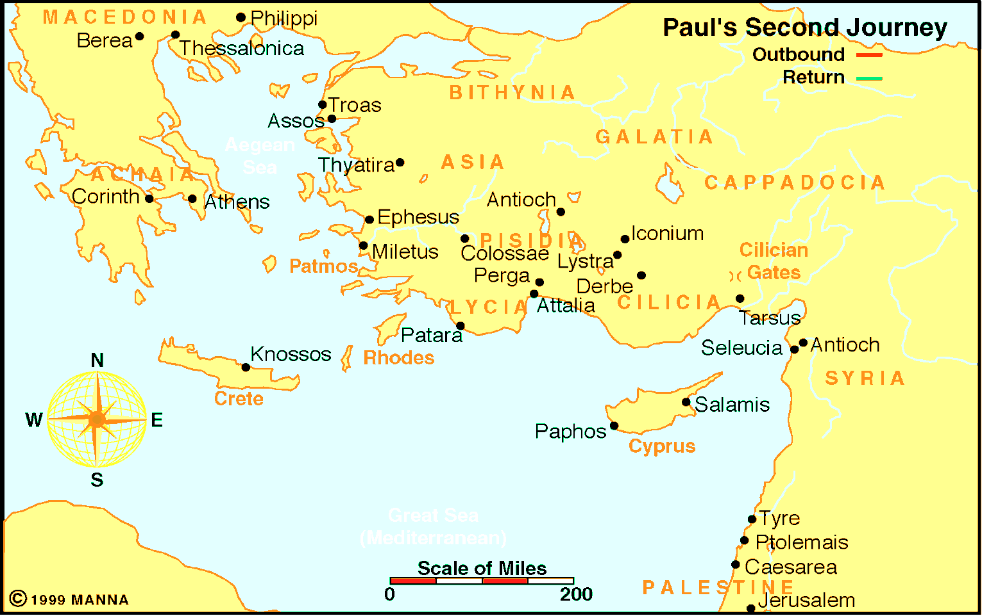

From Antioch to Athens

Application:
Be prepared to discuss what lessons can learn from these events, and how those lessons can be applied to present-day situations.

