Acts of the Apostles
A Study of New Testament History
Lesson 13
Acts 13:1 – 14:28

Introduction:
In the thirteenth and fourteenth chapters of Acts we read of the first missionary journey of Paul and Barnabas. This journey will cover a period of approximately two to three years. After departing from Antioch of Syria, Paul and Barnabas travel to Cyprus where they preach the gospel of Christ in Salamis and Paphos. From there, they sail to the mainland of Asia Minor where they travel through Perga to preach the gospel in the cities of Antioch in Pisidia, Iconium, Lystra and Derbe.
During this missionary journey several notable events occur:
- Salamis
  - Preached to the Jews in Synagogue
- Paphos
  - Sergius Paulus desired to hear the word of God
  - Elymas tries to turn him away from the faith
  - Saul is referred to as Paul for the first time
  - Now it is "Paul and Barnabas" not "Barnabas and Saul"
- Perga
  - John Mark (writer of Mark) turned back and returned to Jerusalem
- Antioch Pisidia
  - Paul preached at least two Sabbaths
  - Paul’s 1st recorded sermon
  - Sermons of Peter and Stephen had the same theme
- Iconium
  - Departed from Antioch because of severe persecution
  - Paul preached in the synagogue
  - Jews and Gentiles converted
  - Unbelievers tried to stone Paul and Barnabas
- Lystra
  - Lame man healed
  - People of city thought Paul and Barnabas were gods
  - Jews from Antioch and Iconium came and stirred up trouble – Paul was stoned, left for dead

- Derbe
  - Many disciples added
  - Farthest point of travel on first missionary journey

In all, Paul and Barnabas traveled approximately 1,200 miles (480 miles by sea) and established at least seven congregations in the process. However, it was a missionary journey during which Paul would pay a heavy price for his faithfulness. In his final letter to Timothy, the apostle Paul sought to encourage the young evangelist by recalling some of the events that took place during this first missionary journey.

But you have carefully followed my doctrine, manner of life, purpose, faith, longsuffering, love, perseverance, persecutions, afflictions, which happened to me at Antioch, at Iconium, at Lystra — what persecutions I endured. And out of them all the Lord delivered me. Yes, and all who desire to live godly in Christ Jesus will suffer persecution. (2 Timothy 3:10-12)

This would not be the last time Paul would suffer persecution for his work as an apostle of Jesus Christ. He will suffer from an undisclosed illness, be beaten and put in prison, threatened with the loss of his life, and be repeatedly accused by his enemies everywhere he went.

Memorization:
"We must through many tribulations enter the kingdom of God." (Acts 14:22)
Key Events of Acts 13-14:
- First missionary journey of Paul and Barnabas
- Paul is stoned and left for dead in Lystra

Link to Online Bible Study Tools:
These websites contain numerous Bible Versions and Translations, Concordances, Dictionaries, Lexicons and many other useful tools: http://biblos.com/ and http://www.biblestudytools.com/ (Click on "Our Library" at the top of the home page)

The Exposition:
I. First Missionary Journey (Acts 13:1 – 14:28)
A. Barnabas and Saul Called (Acts 13:1-3)
1. Where were Barnabas and Saul when called by the Holy Spirit?

2. What do you think the purpose for fasting and praying on this occasion would be?

3. What would be the purpose for laying hands on Barnabas and Saul? Consider a similar event in 1 Timothy 4:14.

B. Preaching in Cyprus (Acts 13:4-12)
1. Where was the first place Barnabas and Saul preached?

2. Why would they choose to preach in the synagogues there? Explain.

3. Who was with Barnabas and Saul?

4. Where did Barnabas and Saul go next and what happened there?

C. Antioch in Pisidia (Acts 13:13-50)
1. List the cities Paul and Barnabas traveled through up to this point on their way to Antioch Pisidia.

2. Who deserted Paul and Barnabas at Perga in Pamphylia and where did he go?

3, Where did Paul and Barnabas go when they arrived in Antioch in Pisidia and what did they do?

4. According to Paul, who was the "seed" of David whom God raised up?

5. Who preached the baptism of repentance before Jesus?

6. According to Paul, how did the rulers in Jerusalem fulfill the voices of the prophets?

7. What proofs does Paul offer to show Jesus was resurrected from the dead?

8. Paul showed that the two psalms of David concerning the resurrection could not have been speaking of David. Where was the first time this same argument was made?

9. What would the preaching of Christ do for those who had been under the Law of Moses?

10. After the Jews left the synagogue, who approached Paul and Barnabas and what did they want?

11. Why would Paul and Barnabas choose to preach again on the following Sabbath? Were they keeping the Sabbath as a day of worship?

12. What was the reaction of the Jews?

13. What did Paul say in response?

14. What was the reaction of the Gentiles?

15. As the word of God spread throughout the region what did the Jews do?

D. Iconium (Acts 13:51 – 14:7)
1. Where did Paul and Barnabas go upon arrival in Iconium, what did they do there and what was the result?

2. What did the unbelieving Jews do?

3. What did Paul and Barnabas do, and what was the response of the people of Iconium?

4. What prompted Paul and Barnabas to flee from Iconium?

5. Where did Paul and Barnabas go next?

E. Lystra (Acts 14:8-20)
1. What was the first thing Paul did upon arriving in Lystra?

2. What was the reaction of the people, and who did they believe Paul and Barnabas were?

3. What was the reaction of Paul and Barnabas?

4. What did Paul want the people to turn from, and what did he urge them to turn to?

5. What happened to Paul in Iconium and who was responsible?

6. Where did Paul and Barnabas go next?

F. Derbe (Acts 14:21)
1. What was the result of the preaching of Paul and Barnabas in Derbe?

G. Return Trip (Acts 14:21-28)
1. What cities did Paul and Barnabas go through on their return trip and what did they do in each city?

2. What did Paul and Barnabas do upon their arrival in Antioch of Syria?

3. Trace the journey of Paul and Barnabas on their first missionary journey.

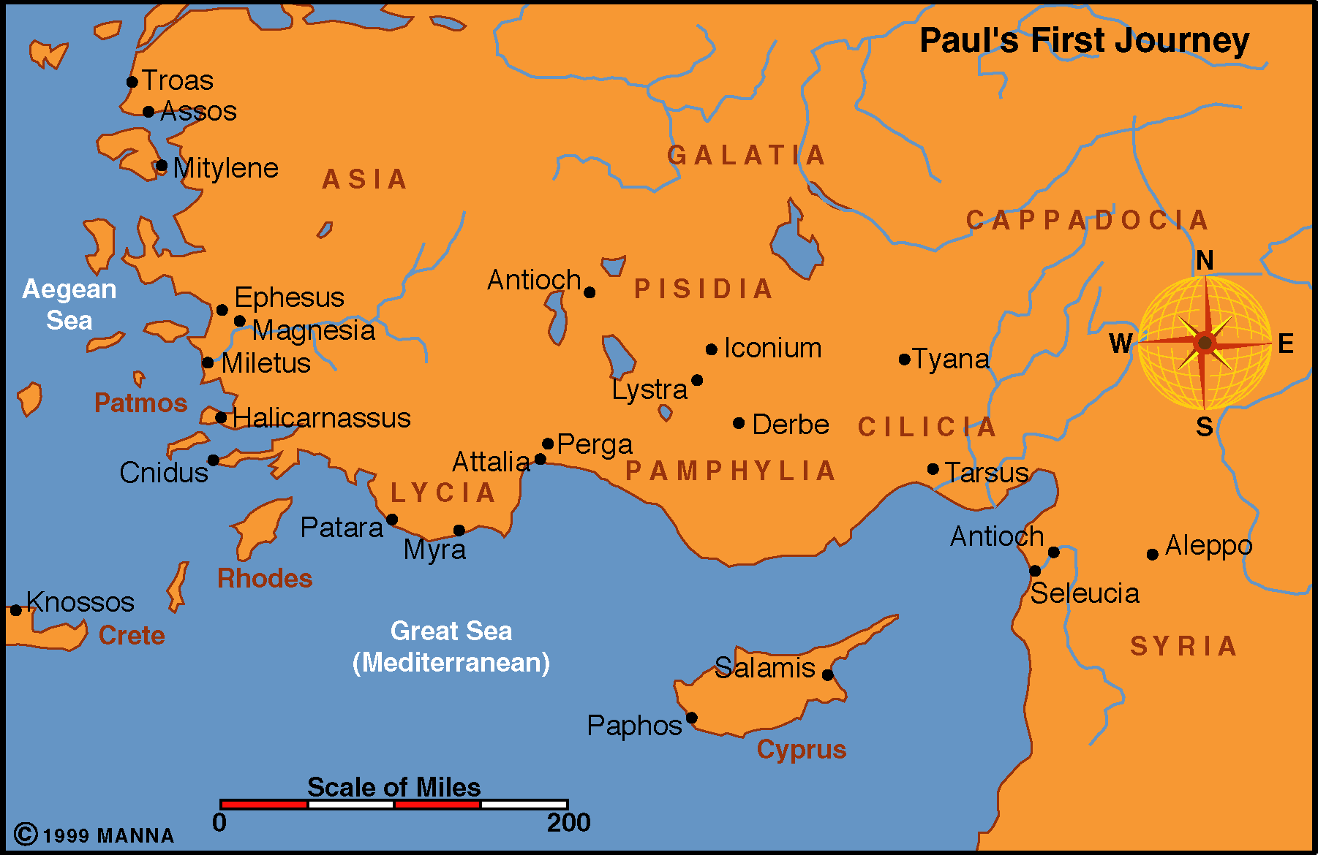

Application:
Be prepared to discuss what lessons can learn from these events, and how those lessons can be applied to present-day situations.

