Acts of the Apostles
A Study of New Testament History
Lesson 11
Acts 11:1-30

Introduction:
With the conversion of Cornelius and his household, remission of sins through the blood of Jesus Christ was clearly for Jew and non-Jew (Gentile) alike. Now it was time to take the soul-saving message of the gospel of Christ into the world.
Before His ascension into heaven, Jesus gave His disciples the great commission to take the gospel to all nations.

And Jesus came and spoke to them, saying, "All authority has been given to Me in heaven and on earth. Go therefore and make disciples of all the nations, baptizing them in the name of the Father and of the Son and of the Holy Spirit, teaching them to observe all things that I have commanded you; and lo, I am with you always, even to the end of the age." (Matthew 28:18-20)

And He said to them, "Go into all the world and preach the gospel to every creature. He who believes and is baptized will be saved; but he who does not believe will be condemned. And these signs will follow those who believe: In My name they will cast out demons; they will speak with new tongues; they will take up serpents; and if they drink anything deadly, it will by no means hurt them; they will lay hands on the sick, and they will recover." (Mark 16:15-18)

Then He said to them, "Thus it is written, and thus it was necessary for the Christ to suffer and to rise from the dead the third day, and that repentance and remission of sins should be preached in His name to all nations, beginning at Jerusalem. And you are witnesses of these things. Behold, I send the Promise of My Father upon you; but tarry in the city of Jerusalem until you are endued with power from on high." (Luke 24:46-49)

However, the Lord intended for the spread of the gospel to follow a logical progression from Jerusalem, into Judea and Samaria, and then into the whole world.

And being assembled together with them, He commanded them not to depart from Jerusalem, but to wait for the Promise of the Father, "which," He said, "you have heard from Me; for John truly baptized with water, but you shall be baptized with the Holy Spirit not many days from now." Therefore, when they had come together, they asked Him, saying, "Lord, will You at this time restore the kingdom to Israel?" And He said to them, "It is not for you to know times or seasons which the Father has put in His own authority. But you shall receive power when the Holy Spirit has come upon you; and you shall be witnesses to Me in Jerusalem, and in all Judea and Samaria, and to the end of the earth." (Acts 1:4-8)

The gospel was first preached to those who were most familiar with the Old Testament prophecies concerning the coming of the Messiah – the Jews. They had been God's chosen people and had been entrusted with the Law of Moses which God used as a tutor to bring the nation of Israel to Christ. However, as Paul told the Galatians, after the Law brought the Jews to Christ it would have served its purpose and would no longer be needed.

But before faith came, we were kept under guard by the law, kept for the faith which would afterward be revealed. Therefore the law was our tutor to bring us to Christ , that we might be justified by faith. But after faith has come, we are no longer under a tutor. (Galatians 3:23-25)

Now that countless numbers of Jews had been converted to Christ through the gospel, and the infant church was rapidly spreading into Jewish communities throughout the world, it was now time to share that message with Gentiles.

While Acts chapter 8 detailed the preaching of the gospel to the Samaritans, and Acts chapter 10 provided the account of the first Gentile converts, Acts chapter 11 sets the stage for the work of Saul of Tarsus (Paul) – the man whom God had chosen to take the message of Jesus Christ into the world of Greeks and Romans.

Memorization:
And the disciples were first called Christians in Antioch. (Acts 11:26b)
Key Events of Acts 11:
- Peter defends the conversion of Cornelius and his household
- Barnabas and Saul preach in Antioch
- Relief sent to needy saints in Judea

Link to Online Bible Study Tools:
These websites contain numerous Bible Versions and Translations, Concordances, Dictionaries, Lexicons and many other useful tools: http://biblos.com/ and http://www.biblestudytools.com/ (Click on "Our Library" at the top of the home page)

The Exposition:
I. Peter defends the conversion of Cornelius and his household (Acts 11:1-18)
A. Controversy arose over Peter going to a Gentile (Acts 11:1-3)
1. Who are "those of the circumcision"?

2. Why did they contend with Peter?

3. How would you use this controversy to show Peter was not considered a Pope (the vicar of Christ upon earth)?

B. Peter defends the preaching of the gospel to Gentiles (Acts 11:4-18)
1. What is the first evidence Peter offers to prove this was all from God?

2. How does Peter use the Holy Spirit as further evidence to prove this was approved of God?

3. What is the third piece of evidence Peter offers to prove he has witnesses to back up his testimony?

4. What evidence does Peter offer from the testimony of Cornelius to prove this was all from God?

5. What is the final evidence Peter offers to conclude that God intended for Cornelius and his household to be baptized?

6. Where did the Lord say, "John indeed baptized with water, but you shall be baptized with the Holy Spirit"?

7. What was the specific "gift" of the Holy Spirit that was given to the apostles and to the household of Cornelius alike?

8. Is this the "gift of the Holy Spirit" promised to all who repent and are baptized (Acts 2:38)? Why or why not?

9. What did Peter say in conclusion that would make it difficult for anyone to refuse to accept Gentiles as fellow believers?

10. What was the reaction of those who heard Peter's story?

II. Barnabas and Saul (Acts 11:19-26)
A. Antioch (Acts 11:19-24)
1. Identify the following locations on the map below: Phoenicia, Cyprus, and Antioch.

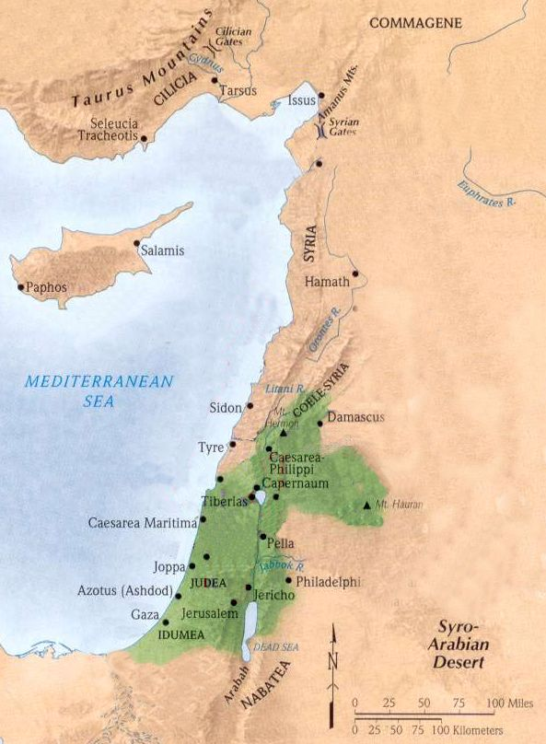

2. Where is Cyrene located and where is the first time this place is mentioned in Acts?

3. Who are the Hellenists and where did the name originate?

4. What was the effect of preaching "the Lord Jesus" to the Hellenists in Antioch?

5. Why did the church in Jerusalem send Barnabas to Antioch and what did he do there?

6. How does Luke describe Barnabas?

B Barnabas and Saul in Antioch (Acts 11:25-26)
1. Where did Barnabas go after leaving Antioch and what was his purpose?

2. How long did Barnabas and Saul assemble with the church in Antioch and what did they do during this time.

3. What were the disciples called in Antioch?

III. Relief sent to needy saints in Judea (Acts 11:27-30)
A. Agabus (Acts 11:27-28)
1. What is a prophet and what kind of work did they do?

2. How did one become a prophet? (See: Romans 12:6; 1 Corinthians 12:10, 28; 13:2, 8; 14:3, 5, 24)

3. Based on the passages above do we still have these same kind of prophets in the church today? Explain your answer.

4. What did Agabus prophesy and when was this to occur?

5. Consult a reference source to give the approximate years when this may have occurred.

B. Sending relief to Judea (Acts 11:29-30)
1. What were the disciples in Antioch determined to do?

2. Who were the intended recipients of this "relief"? (Also consider 2 Corinthians 8:4; 9:1, 12)

3. Who would be excluded by this "relief" and why?

4. What does Galatians 6:10 teach about doing good "to all, especially to those who are the household of faith"?

5. Was Paul speaking of benevolence by churches in Galatians 6:10 or by individual Christians? Consider the context of Galatians 6:1-10 to explain your answer.

6. Where were "the elders" located to whom Barnabas and Saul delivered the "relief" from the church in Antioch?

7. From our previous studies in Acts, list some of the cities in Judea where brethren dwelled?

8. Based on the following passages how many churches were to have elders, and what limitations are placed on the jurisdiction and oversight of elders? (Acts 14:23; 20:28; 1 Peter 5:2-4)

9. If the disciples in Antioch sent "relief" to "the elders" in Jerusalem to then be distributed by those elders to needy churches in Judea, this would be an example of a "sponsoring" or "overseeing" eldership. Is that what this passage illustrates? Use the passages mentioned in question 5 above to explain your answer.

10. What are some differences between the example of benevolence in 1 Corinthians 16:1-4 and the one mentioned here in Acts 11:29-30?

Application:
Be prepared to discuss what lessons can learn from these events, and how those lessons can be applied to present-day situations.

